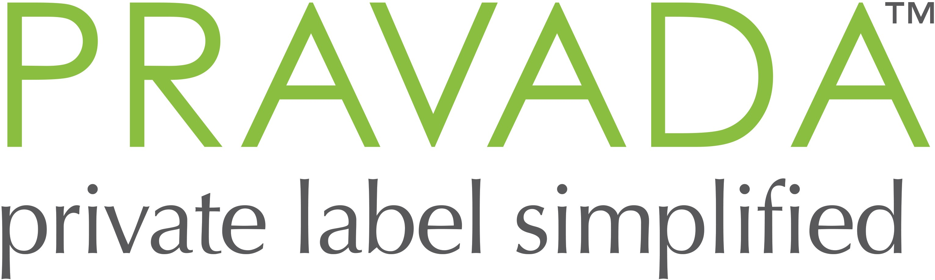

Material Safety Data Sheet

Section 1: Chemical Product and Company Identification
Product Name:  Advanced Smoothing Crème | Product Use:  Skin Care Formulations
Manufacturer Company Name:  Pravada LLC, | Manufacturer Company Address:  1501 Rail Head Blvd.  Naples, FL 34110
Non-Emergency Telephone Number:  239-260-9826 ext 101 | Emergency Telephone Number:  239-250-8585
Section 2: Hazards Identification
Hazardous Components: None
Section 3: Composition/Ingredient Information
Non Hazardous composition withheld to protect trade secrets
Section 4: First Aid Measures
Eye Contact: In case of contact, flush eyes with plenty of water for at least 15 minutes. Get medical attention if irritation occurs.
Skin Contact: If irritation occurs, wash affected skin with water for 15 minutes. Get medical attention if irritation occurs.
Inhalation: Remove to fresh air. Get medical attention if irritation occurs.
Ingestion: Do not induce vomiting.
Drink one or two glasses of water. Get medical attention if irritation occurs.
Section 5: Fire and Explosion Data
Flash Point: Not Tested
LEL: Not Established UEL: Not Established
Extinguishing Media: Not Tested
Special Firefighting Procedures: None
Unusual Fire and Explosion Hazards: None
Section 6: Accidental Release Measures
Steps to be Taken in Case Material is Released or Spilled:
- Small Spill: Wipe area with dry cloth
- Large Spill: Use dry cloth, scoop larger quantities into buckets
Section 7: Handling and Storage
Store in a sanitary environment
Section 8: Exposure Controls/Personal Protection
Respiratory Protection: Evaluate need based on particular application
Ventilation: None Required
Protective Equipment:
- Gloves: Suggested for safety protection
- Goggles: Suggested for safety protection
Other Protective Clothing or Equipment: Evaluate need based on particular application
Work/Hygienic Practices: Normal work and hygienic practices for handling non-hazardous liquid material

Section 9: Physical and Chemical Properties
Boiling Point: Not Tested
Specific Gravity (H 2O = 1): Not Tested
Vapor Pressure (mm Hg.): Not Tested
Melting Point: Not Tested
Vapor Density (Air = 1): Not Tested
Evaporation Rate (Butyl Acetate = 1): Not Tested
Solubility in Water: Not Tested
Appearance and Odor: White to o white cream. Odor characteristic.
Section 10: Stability and Reactivity Data
Stability: Not Tested
Incompatibility: Not Tested
Hazardous Decomposition or Byproducts: Not Tested
Hazardous Polymerization: Not Tested
Conditions to Avoid: Not Tested
Section 11: Toxicological Information
Routes of Entry:
• Inhalation: Not Tested
• Skin: Not Tested
• Ingestion: Not Tested
Health Hazards: Not Tested
Carcinogenicity: Not Tested
NTP: Not Tested
IARC Monographs: Not Tested
OSHA Regulated: Not Tested
Signs and Symptoms of Over Exposure: Not Tested
Medical Conditions Generally Aggravated by Exposure: Not Tested
Section 12: Ecological Information
Not Tested
Section 13: Disposal Considerations
Waste Disposal: Waste must be disposed of in accordance with federal, state and local environmental control regulations.

Section 14: Transport Information
General: Not Regulated
DOT Shipping Name: N/A
ADR/RIC Code: N/A
Sea Transport IMDG Code: N/A
Air Transport IATA: N/A
Section 15: Other Regulatory Information
Federal and State Regulations:
- TSCA 8(b) Inventory: N/A
- Other Regulations: N/A
- EINECS: N/A
Other Classifications:
- WHMIS (Canada): N/A
- DSCL (EEC): NA
- HMIS (USA): Health Hazard: Not Tested, Fire Hazard: Not Tested, Reactivity: Not Tested, Personal Protection: Not Tested
- National Fire Protection Association (USA): Health: Not Tested, Flammability: Not Tested, Reactivity: Not Tested, Specific Hazard: Not Tested

Section 16: Other Information
This information is provided for documentation purposes only. The complete range of conditions or methods of use are beyond our control therefore we do not assume any responsibility and expressly disclaim any liability for any use of this product. Information contained herein is believed to be true and accurate however, all statements or suggestions are made without warranty, expressed or implied, regarding accuracy of the information, the hazards connected with the use of the material or the results to be obtained from the use thereof. Compliance with all applicable federal, state, and local laws and local regulations remains the responsibility of the user. This safety sheet cannot cover all possible situations which the user may experience during processing. Each aspect of your operation should be examined to determine if, or where, additional precautions may be necessary. All health and safety information contained in this bulletin should be provided to your employees or customers.

Date: July 10, 2018

